**Engineering Workshop**

**(4EJ504)**

**Assignment 2**

**Mini Project Design and Build – Cable Tester**

**Programme(s): BEng Electrical & Electronic Engineering**

**BSc Electrical & Electronic Engineering**

**FdEng Electrical & Electronic Engineering**

**BSc Sound, Light & Live Event Technology**

**BSc Broadcast Engineering and Live Event Technology**

**Assessment Number: 2 of 2**

College of Engineering and Technology

**Assessment Weighting: 70% of module**

**Learning Outcomes Assessed: 2**

**Week Set: 24th September 2018**

**Submission Date: 14th December 2018**

**Module Leader: David Wilson**

[**D.Wilson@Derby.ac.uk**](mailto:D.Wilson@Derby.ac.uk)

**MS225**

**X3202**



**Assignment Brief**

To develop your appreciation of engineering processes, your practical skills in basic engineering and your ability to interpret, construct and test electronic circuits.

**The Task:**

1. Transfer the schematic diagram shown overleaf into the Multisim Schematic Editor ensuring that the components selected match those given both in function and footprint.
2. Forward annotate this to Ultiboard and design a PCB layout which will fit into the given enclosure.
3. Identify components, drill, test, populate and solder the circuit board made from a given design.
4. Mark out and drill the case, then attach connectors, switches and LEDs, paying particular attention to future maintenance.
5. Test, and if necessary troubleshoot and correct any problems found in the project.

The project is a tried tested design and is known to work. If assembled correctly there is no reason why your own circuit will not work. Therefore, it is expected that a fully working circuit will be shown to your tutor.

This assignment is also available on Course Resources under ‘Study Materials’.

**The project box must be assessed by your tutor by the last lab session and this lab book along with a printed out version of your schematic diagram and PCB layout handed in to the Student Centre at Britannia Mill with the marks grid completed and signed by your lab tutor.**

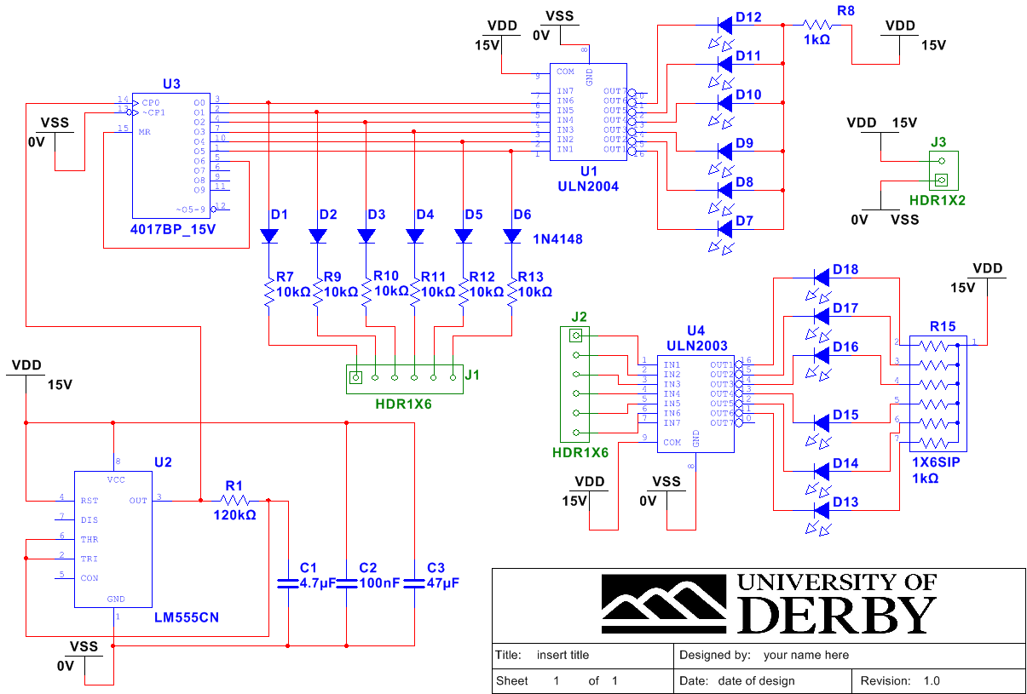

**Since this is a known working design a good pass can only be achieved if a fully working product is submitted.**

For this exercise you will be awarded marks according to the evidence presented in each of the areas in the table below.

### Assessment Marking Grid

|  |  |  |  |  |  |
| --- | --- | --- | --- | --- | --- |
|  | Unsatisfactory(-3.0) | Poor(0.0) | Acceptable **(1.5)** | Good **(3.0)** | Excellent **(5.0)** |
| Schematic Diagram |  |  |  |  |  |
| PCB Layout Design |  |  |  |  |  |
| Internal Wiring. |  |  |  |  |  |
| Quality of soldering |  |  |  |  |  |
| Enclosure Design |  |  |  |  |  |
| PCB Preparation |  |  |  |  |  |
| Component Placement |  |  |  |  |  |
| Operation. |  |  |  |  |  |
|  |  |  |  | Total |  |

**It is imperative that the mini lead tester is demonstrated to be FULLY working to the lab tutor and have this sheet signed to indicate this before you hand in the workbook. Without this signature there is no evidence that you have successfully been able to construct a working product. This would constitute a learning outcome failure.**

**Don’t forget to also hand in a printed out version of your schematic diagram and PCB layout.**

**Academic Signature:**

Date: